

ANNUAL CLIENT SURVEY

REPORT 2023

Prepared by Tara Doyle, Quality Manager

March 2024

Classification: Public, personal information deidentified

|  |
| --- |
| **Job-matching | Training | Support | Careers** |
| [**www.bizlink.asn.au**](http://www.bizlink.asn.au)  **1300 780 789** |

# PURPOSE

This survey is for DES commenced clients who have an email (although those without could use a link / QR code). Clients were not included who had a tag of either: Not for QA as per CATSARI, No Bizzybodies (clients tagged with this, do not want to be on mailing lists), Survey No.

At 08/02/2024, 1018 emails were sent, and the survey closed 26/02/2024. We had 88 clients with no email entered (last survey 107). Only 26 were tagged “email none” some with this tag have an email, but don’t like us using it. Staff need to ensure email contact is entered or add the Tag “email none”.

The survey was promoted via Socials (Facebook / Instagram). There were posters in the offices with a QR Code for easy access. 93 (9%) of surveys sent were returned last year 8%. The square root of 1018 (number of surveys sent) is 31, so the sample of 93 is a good return rate. Whilst 13 were partial, they had completed some sections, so have been included.

Clients had a choice to complete the survey online, to receive a hard copy and post back or to do over the phone. Of the 93 respondents, 1 completed the survey online (via the weblink promoted on Socials, office poster and via Coordinators), 92 used the email link.

# CONFIDENTIALITY

Comments have been deidentified to maintain confidentiality. Comments are copied as written, i.e. they are not edited except for obvious typos. This is to ensure the intention of what was being said is not changed.

# QUESTION RESPONSES

## Q1. Your details (this question is optional but is needed for any follow up)

|  |  |  |
| --- | --- | --- |
| Answer Choices | Responses | |
| Your Name | 100% | 78 |
| Preferred Contact Details (mob/email) | 99% | 77 |
| Can BIZLINK contact you to discuss your survey? (yes/no) | 95% | 74 |
|  | **Answered** | **78** |
|  | **Skipped** | **15** |

## Q2. How Satisfied are you with your Job Plan?

Every client should have a current Job Plan (not more than 3 months old if looking for work and not more than 6 months old if working). Your Job Plan should be reviewed with you and include your career goals. My Job Plan:

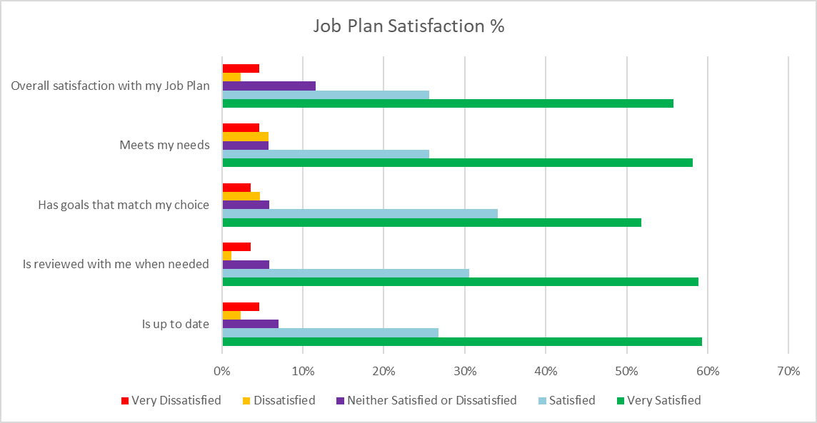

|  |  |  |  |  |  |
| --- | --- | --- | --- | --- | --- |
|  | Very Satisfied | Satisfied | Neither Satisfied or Dissatisfied | Dissatisfied | Very Dissatisfied |
| Is up to date | 59% | 27% | 7% | 2% | 5% |
| Is reviewed with me when needed | 59% | 31% | 6% | 1% | 4% |
| Has goals that match my choice | 52% | 34% | 6% | 5% | 4% |
| Meets my needs | 58% | 26% | 6% | 6% | 5% |
| Overall satisfaction with my Job Plan | 56% | 26% | 12% | 2% | 5% |

Comments:

* Coordinator is helpful, friendly and understanding.
* Coordinator is always on the ball
* I'm very happy with Coordinator, she's caring and understanding and knows her job.
* Coordinator’s been super supportive and wonderful!
* it’s so nice that someone actually listens to me, thank you
* I have not had any contact since deciding to look for additional work 3 months ago, My employer was not giving me any hours of work in my current role. It was only when my someone not associated with Bizlink intervened and helped me by sending an email to my employer's HR team that I got work allocated again.
* I am Client’s carer. In my opinion we are very satisfied with the help Client receives. As Client is basically nonverbal his Coordinator's contact me to let me know how things are going and if they need help.
* Great work guys :)
* Highly recommended always available when needed supported which is important for good service
* Coordinators Nothing is to much trouble Both go above and Beyond Provide me with positive solutions when I'm feeling sorry for myself
* Don't bother with job plans
* Any offer I had were not fruitful
* Pretty standard Job Plan, more focused on your internal processes rather than clients needs. The whole 3 month renewal process is pretty impersonal and clients are given approx 24hrs to return which shows it is more for administrative reasons not client focused, around individual needs.
* Coordinator is the young intelligent girl who has been very though in helping me with my job plan, being that I have so many medical conditions she never gives up on me. I have been persistent in wanting to work from home or part time work that I don't stand or sit for to lone. I don't want to give up on myself as I think I would be just counting down on time I have left.
* I feel Bizlink had little power of influence to make real difference with people disabilities and difficulties in the workforce. Too much goes under the radar where needs are simply being half fulfilled or not at all.
* Would be good if we could have a flexible option for when we have down seasons and are expected to get less hours, such as retail so we aren't asked to look for new employment every time this happens.
* My dealings with Coordinator and Coordinator are always on-point and incredibly helpful! I would be lost without their support.
* I have had no problems.
* No
* Can u plz find me work asap and work experience .

## Q3. Has a Job Search Coordinator provided help to find a job over the past 12 months?:

This is a navigation question i.e. directs respondent to appropriate section of survey dependent on response.

|  |  |  |
| --- | --- | --- |
| Answer Choices | Responses | |
| Yes - answer the job search questions | 58% | 49 |
| No - I have worked for last 12 months - go to next section | 42% | 35 |
|  | **Answered** | **84** |
|  | **Skipped** | **9** |

## Q4. How satisfied (happy) are you with the help from your Job Search Coordinator to find a job?

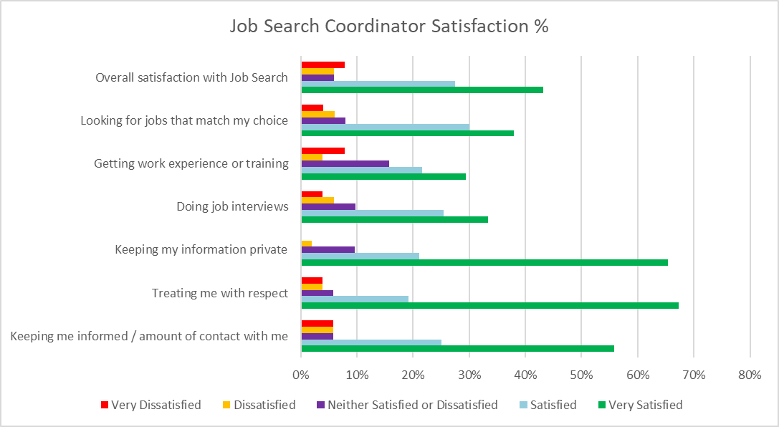

|  |  |  |  |  |  |
| --- | --- | --- | --- | --- | --- |
|  | Very Satisfied | Satisfied | Neither Satisfied or Dissatisfied | Dissatisfied | Very Dissatisfied |
| Keeping me informed / amount of contact with me | 56% | 25% | 6% | 6% | 6% |
| Treating me with respect | 67% | 19% | 6% | 4% | 4% |
| Keeping my information private | 65% | 21% | 10% | 2% | 0% |
| Doing job interviews | 33% | 25% | 10% | 6% | 4% |
| Getting work experience or training | 29% | 22% | 16% | 4% | 8% |
| Looking for jobs that match my choice | 38% | 30% | 8% | 6% | 4% |
| Overall satisfaction with Job Search | 43% | 27% | 6% | 6% | 8% |

Comments:

* In well over 12 months, nothing has been found for me.
* Most meaningful productive positive supporting and understanding assistance I've received in all my life. The people who assist me couldn't do a better job.
* Great:)
* Thankyou Bizlink
* I advised Satisfied instead of Very Satisfied as there was service lacking on the recruitment end. Email questions and some texts that were ignored even when followed up a week later. When I was suggested certain jobs/companies and I would follow up on them to ask if the recruiter had or planned to gain a contact at that company (especially given I am a DES client). I was met with a no and that’s it, no further work on the recruiters end. It would be my job to make the contacts? So yes, I got mainly moral support for job searching but did not get much professional assistance/direct action/interview training. This is to be honest on my experience, and makes me feel that getting DES clients into any role than into the long term role they truly want to pursue is not put as a priority as much as stated by BizLink. Once you’re in a role that may as well be it. An example of this is I’m in a starting role (retail) but I’m currently going for another role (banking work from home) that I truly want long term and suits my current skills. However after reaching out to the recruiter who originally suggested it, I was told she had no contacts there and that’s it, so I’m currently managing finding an internal DES contact at that company and the whole interview process by myself now.
* Only getting jobs that don’t suit me/I’m capable of doing and that are to far away, even though I’ve discussed this when a signed up.
* I have not worked in 5 yrs due to my medical conditions and finding someone that are willing in hiring me because of these conditions.
* Given the companies that hire people that BIZLINK consider to be "terrific employers" I feel it should perhaps review it choices of where it can find work for people. I find it has been impossible to find a job to replace the current one as I feel the rights are rather primitive and unfair reflexive of a bygone era. Too many have too little working rights with inadequate pay to match the cost of living crisis.
* I was offered a job with better pay thanks to Coordinator.
* I had to decline due to difference of opinion with my wife. She argues that cost of transport would make it unviable
* It's been great to be able to contact them any [day] time and have quick feedback/responses from them.
* It doesn't seem like I am on the priority list, perhaps it's been lost?
* Everyone has been great to work with.

## Q5. Are you currently working?

This is a navigation question i.e. directs respondent to appropriate section of survey dependent on response.

|  |  |  |
| --- | --- | --- |
| Answer Choices | Responses | |
| Yes - answer work-related questions | 41% | 20 |
| No - but I have worked over the past 12 months and want to answer the work-related questions | 12% | 6 |
| No - skip to next section | 47% | 23 |
| Any comments |  | 0 |
|  | **Answered** | **49** |
|  | **Skipped** | **44** |

## Q6. When thinking about your current job:

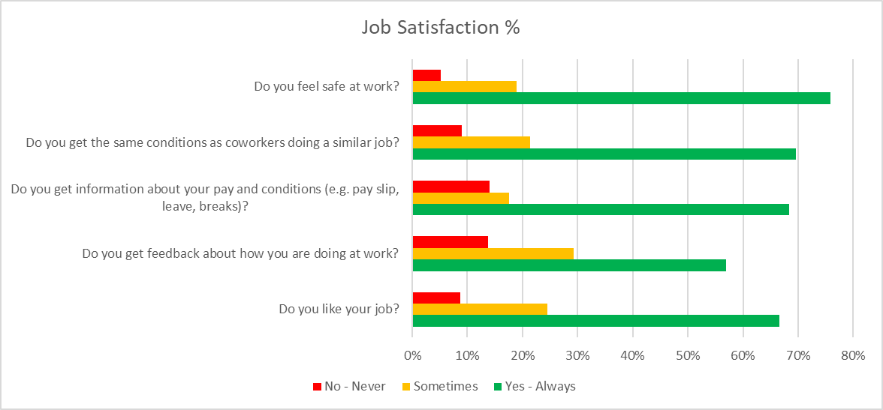

|  |  |  |  |
| --- | --- | --- | --- |
|  | Yes - Always | Sometimes | No - Never |
| Do you like your job? | 67% | 25% | 9% |
| Do you get feedback about how you are doing at work? | 57% | 29% | 14% |
| Do you get information about your pay and conditions (e.g. pay slip, leave, breaks)? | 68% | 18% | 14% |
| Do you get the same conditions as coworkers doing a similar job? | 70% | 21% | 9% |
| Do you feel safe at work? | 76% | 19% | 5% |

Comments:

* Coordinator always keeps up to date with what's going on at work he really has his finger on the pulse
* I do not know the answer to Q3 - but "do not know" is not an option. Work is very important to me and I am always punctual and do my best - I would like more hours but am not clear on how to ask for this and do not get support from Bizlink to work with my employer to do this.
* I cannot answer the above questions as they relate to Client only I would think that the answer to these questions is Yes.
* All good there is a time need support
* Yes I have developed good communication skills between myself and my current employer.
* My current employer have a model of working that I feel to be both obsolete and both dismissive.
* I have had no Official training, I had to figure everything out myself with near to no assistance. When seeking assistance it feel like a burden or an inconvenience to do so. I find this to be the result of the generation of older workers and employers who are in charge of me.
* Coworkers are getting better pay rate- its casual I am full timer
* As a customer greeter at employer you can get verbal abuse and put in threatening situations, calling security can only do so much, but it is a good work environment and my managers have my back for these instances.
* Ironically I found this through word of mouth via a friend. I have put in considerable numbers of applications to zero effect!
* I'm only volunteering at this point.

## Q7. How satisfied (happy) are you with your Support Coordinators help to keep your job?

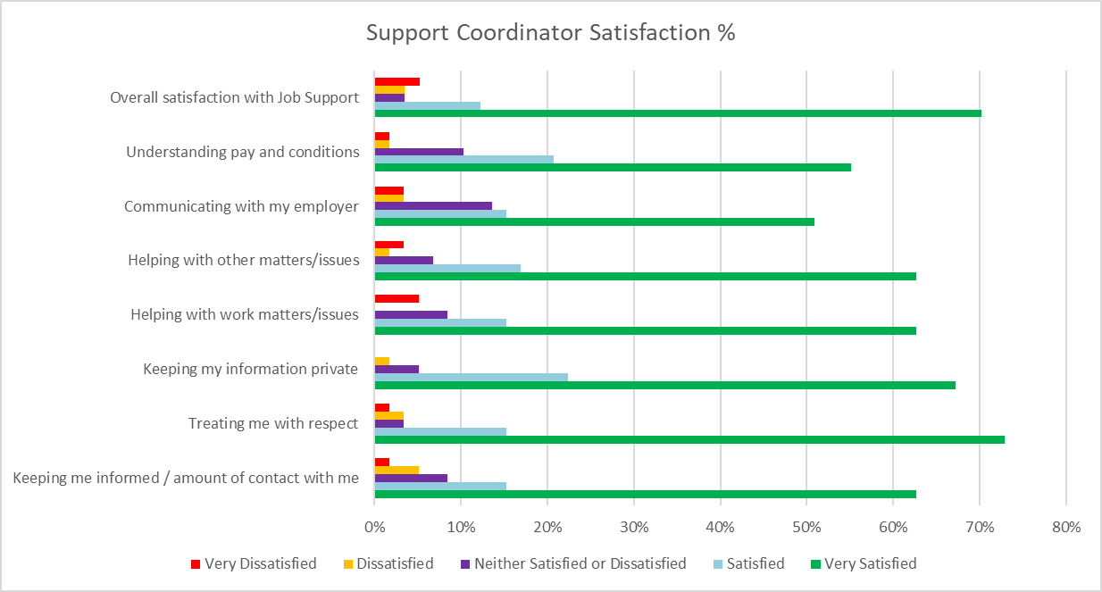

|  |  |  |  |  |  |
| --- | --- | --- | --- | --- | --- |
|  | Very Satisfied | Satisfied | Neither Satisfied or Dissatisfied | Dissatisfied | Very Dissatisfied |
| Keeping me informed / amount of contact with me | 63% | 15% | 8% | 5% | 2% |
| Treating me with respect | 73% | 15% | 3% | 3% | 2% |
| Keeping my information private | 67% | 22% | 5% | 2% | 0% |
| Helping with work matters/issues | 63% | 15% | 8% | 0% | 5% |
| Helping with other matters/issues | 63% | 17% | 7% | 2% | 3% |
| Communicating with my employer | 51% | 15% | 14% | 3% | 3% |
| Understanding pay and conditions | 55% | 21% | 10% | 2% | 2% |
| Overall satisfaction with Job Support | 70% | 12% | 4% | 4% | 5% |

Comments:

* Very happy with the help from Coordinator, always there when i need help with speaking to my work , making sure i have a way too and from work , keeping me motivated and checking in to see how I’m doing
* We have had others try to do Coordinator job in the past and they don't come close to the level of serves and professionalism Coordinator shows every day
* No one from Bizlink has visited my employer in a long time, maybe because I mainly work weekends and evenings - so I do not feel there is good communication between Bizlink and my employer . As a result I don't know if I am doing a good job and what I need to do to improve. My job is very important to me and I want to be successful and a valued team member but I need support to do this and do not feel I am getting it.
* Again as Client’s carer I cannot answer these questions but would assume that all is ok.
* I would like to say the team at the Midland store are great especially my job coordinator and the manager.
* I am very grateful and thankful for what they doing for me very much appreciated.
* I don't have any bad things to say about Bizlink Midland All good things
* Only started with my Support Coordinator, only had my first meeting with them and have no comprehensive feedback as of yet.
* I would prefer a screening process where I know of employers who have workers union's. Where treating is Official and on site. Where making something of myself is possible and not impossible.
* Me and Coordinator are friends by now
* Coordinator is AMAZING 👏
* Coordinator contacts me regularly and has interest in my ideas and projects
* I know the support is always there should I need it

## Q8. What do you think would happen to your service if you made a complaint?

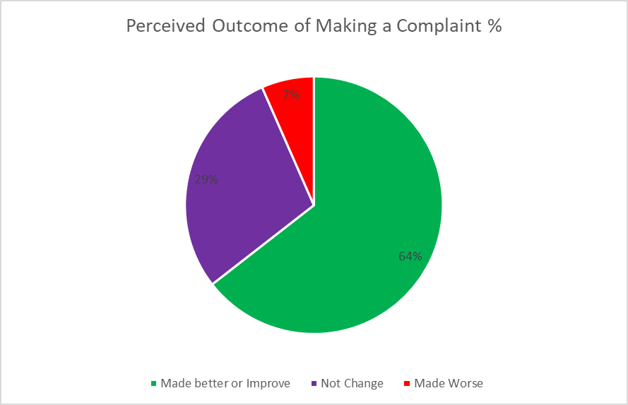

**Comments**:

* no complaints here
* I do not want to make a complaint, I just want to be heard and help Bizlink to help me and improve their service to all their clients.
* No idea
* Well done BIZLINK team keep up with promise support service is important to keep us going with touch base.
* Don't have anything bad to say
* No follow up after offers.
* I mean I’d like to see recruiters standards expected at the same level as their clients. But I doubt my feedback will be listened to and the onus will continue to fall back on the clients.
* Why would I make a complaint with the help and support that Bizlink give to me, all of the people that I have help with my health conditions at Bizlink I am so grateful that I have their support.
* I am happy with professional service Bizlink provides
* I'm not entirely sure as I've never really had to, it's been fine so far
* If a boss really upset me, he had better have funeral insurance, he will need it!
* I know my feedback would be well-received and welcome.
* No
* Have no idea
* I have had 3 Coordinators now that let my Centrelink payments get almost cut off even though I have fulfilled all of my requirements, every single time they forget to report to Centrelink and let Centrelink tell me they are about to cut off my payments within 2 days and then I have to message them to fix it, but it should never happen in the first place they should be reporting to Centrelink that I have completed all of my requirements but they never do literally 3 different coordinators they all did the same thing. It's very scary because I rely on those payments to live and they seem to treat them as not important.
* I have no problems with Bizlink and if there were, I firmly believe they'd be fixed asap from the level of support received.

## Q9. How likely is it that you would recommend BIZLINK to a friend or colleague?

76% of respondents were highly likely to recommend BIZLINK (a score of 7+).

| **DETRACTORS (0-6)** | **PASSIVES (7-8)** | **PROMOTERS (9-10)** |
| --- | --- | --- |
| 24% / 19 | 15% / 12 | 61% / 48 |

## Q10. What do you like most about BIZLINK?

Comments:

* Coordinator is so good and I feel at ease talking to her
* The constant support from Coordinator and never judging me and making sure I am doing my best
* I really enjoy how well the company has been able to provide all the assistance that I have needed.
* Coordinator from the Success branch! He worked with me in the readiness for work modules (I think that is what it was). Friendly, dependable, communicative.
* Convenience and staff
* They are very friendly, helpful and supportive agency.
* The people
* honest support
* Opportunity to be part of a knowledgeable team and learn. Also the opportunity that the business provides to people looking for work with disability.
* No help is there if I need it.
* Coordinator
* I like visiting BIZLINK to see my Coordinator she has a lovely relaxing personality that makes you feel at ease straight away and she's very helpful.
* respect shown to me by Coordinator
* Respect
* They are understanding and provide real help.
* Bizlink are always here to help me and give me advice if needed. I feel like I have their full attention.
* Friendly staff that genuinely care about having a successful outcome for clients
* The people
* Listening and replying
* they listen
* Always asking how I am personally and in my job
* Bizlink helped me to find work with employer that I am very grateful for - but this was over 18 months ago
* As a carer they keep me informed.
* Always ready to help and advise
* Easy to talk to
* It’s a great help for work related matters
* Friendly
* I have found my job search coordinator very understanding and supportive
* Bizlink makes you feel like a person not a number like other disability employment services. I have a speech impediment before I came to Bizlink I was with another disability employment network named X I had to go on my own to job interviews with my speech impediment I didn't have a chance of getting the job. Since I been with Bizlink I have more job interviews and the support of my job coordinator accompanying me to the interview's and helping me.
* My support worker
* They think realistically about needs of customers and help them with things also outside of employment
* Professionalism
* The staff are great. (Mostly.)
* Kind of help
* No as pushy as normal job places and helpful
* I think the staff are friendly and help very much with the moral support for DES clients that are trying to transition back into the workplace.
* Regular contact and support
* Understanding and realistic about presenting vulnerabilities…. Relevant Knowledge and exploring options
* The amazing help and support that they do.
* I am grateful for the assistance of being able to talk to someone about work confidentiality and with privacy.
* Friendly understanding experienced staff
* "The service does not stop after I started job. Support continues on consistent basis.
* Professional , friendly and supportive. Always wanting to help.
* Getting me a job at employer
* I have been treated with respect unlike other DES providers.
* The people
* Understanding of Coordinator and the managers selected at jobs I’ve been put forward to
* Just amazing, the staff are so wonderful to me! I absolutely adore Coordinator, Admin and Coordinator 🥰
* Their patience and unwavering support.
* the attitude of the staff.
* They are very hands on and helping in writing Resumes and Cover Letters.
* The great people there
* I get great support from my coordinator, always gives information kind I have any problems, overall very lovely
* Staff, location, information and service.
* The patience and understanding around my mental health. Not rushing me and moving at my pace. I had a mental break down and still am recovering a year later, but have been able to go at my pace which has allowed me to move forward and not result in having any further decline mentally.
* Dealing with Coordinator very caring and supportive
* The support and work
* Coordinator in Midland office is absolutely amazing at her job and the Midland office is like a big family to me
* They help me with finding a job
* Professionalism
* very friendly and supportive
* That they are very close to home and all the staff have a good sense of humour and the site manager reminds me of Mr Flint Stone.
* Everything
* Staff are all friendly
* Friendly and professional atmosphere..

## Q11. What could BIZLINK do better?

Comments:

* Nothing
* Nothing I think they are doing perfect
* I’m not sure. The job market is tough for differently abled. I really don't think though that the person in charge of my plan did the best job for me. Over a year is a long time to not get job and my skills are going to be harder to recall if I do get one.
* Nothing you are perfect
* Not sure,
* Give Coordinator a pay rise
* I can't think of anything.
* NOTHING
* Nothing
* Not much I am very satisfied with the job they are doing.
* Can't think of anything really
* no complaints
* Nothing
* Be much more proactive in responding to issues and following up requests and much more focused on the key aspects of the purpose . For example my job plan talks about Health and Allied Services assistance which I do not need.
* Doing well as they are
* Everything is fine as it is
* It depending who seeing however I am very happy seeing Coordinator is great mentor helping and guide me in workplace
* Bizlink doesn't need to change anything the service you give to people with disabilities is (second to none) in other words 5 Star in all areas keep up the good work
* Demote the: 'who you know' work industry, drastically lower the amount of paperwork and communicate more about their services.
* They fine
* Help me find a job that actually matches my ambitions.
* Follow up offers
* Listen more
* Instead of assigned recruiters ignoring clients emails and texts and just saying “I was away or sick that week my phone/emails were off”. Maybe instead they should be instructed towards a general contact to use after hours that is forwarded to a admin inbox so staff on duty that week can respond instead. Clients shouldn’t need to follow up a week later and find their questions left unanswered and the recruiters has moved on or deleted them and therefore you never get an answer.
* New to service assisting to get me job ready
* Have a coffee machine to make it feel more like a friendly relaxing chat. lol
* Push harder on employees for more accommodations and training, much more training for people..
* Nothing - all good as you are
* Keep in touch when support worker is away
* Can't do better, excellent support
* Could be better with LGBTQIA+ areas such as preferred name and pronouns, as a lot of people with disabilities (including myself) are usually diverse gender wise in some way shape or form, our entire perception of gender is not the same as neurotypical people, so more awareness and training would be good, to at least ask when first assigned to a client to ask for preferred name and pronouns and to make a conscious effort to use them (mistakes are okay) but as long as there is an effort is all that matters. I find that there isn't a level of transparency, and I'm having to come out to every worker, and it's an awkward position to be in. Just having a note so people know the client's preferred name and pronouns would be good or at least have this as an option for all clients who are gender diverse.
* Can't think of a single thing.
* Nothing
* In my experience at Midland, nothing. Please hold your position as you are. PS: I have already referred you to a friend!
* Find me a job!
* None.
* Not really sure how to answer this one
* Nothing
* Bizlink has been a great support for some time for myself and have found little if anything needing done better.
* Employ more people like Coordinator
* nothing
* Nothing
* Nothing
* Not much
* keep doing what they are doing. they are very supportive for me
* To find me a job, within a week or two. Also taking me to other places with them to find work. To help get me work experience to turn into a job.
* I don't know
* Nothing I can think of.

## Q12. Overall, how satisfied or dissatisfied are you with BIZLINK?:

|  |  |  |
| --- | --- | --- |
| Answer Choices | Responses | |
| Very satisfied 😊👍 | 73% | 58 |
| Satisfied 😊 | 13% | 10 |
| Neither satisfied nor dissatisfied 😑 | 5% | 4 |
| Dissatisfied 😒 | 5% | 4 |
| Very dissatisfied 😠👎 | 4% | 3 |
|  | **Answered** | **79** |
|  | **Skipped** | **14** |

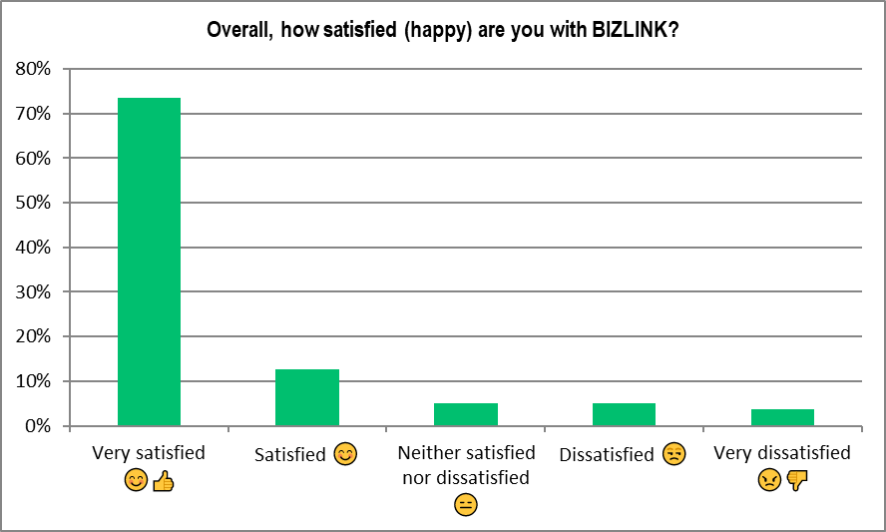

# CONCLUSIONS

The Annual Client Survey aims to determine whether BIZLINK provides a service that meets the expectations of our clients and the National Standards for Disability Services. It is important to take all opinions from the perspective of our clients and use their feedback to improve our service. The results show that that majority of clients who responded to the survey have a positive view on their experience with BIZLINK:

• 81% (2022 92%) were satisfied with their **Job Plan** overall i.e. up-to-date, reviewed when needed, individualized

• 71% (2022 92%) are satisfied with the assistance of their **Job Search Coordinator**

• 82% (2022 92%) are satisfied with the assistance of their **Support Coordinator**

• 65% (2022 60%) felt service would improve if a **complaint** was made

• 76% (2022 89%) would **recommend** **BIZLINK** (that’s a score of 7 to 10)

• 83% (2022 93%) are **satisfied overall** with BIZLINK

People were generally less positive and satisfied with BIZLINK this year i.e. satisfaction generally a few % lower than previous years. Survey results provide encouragement for what we are doing well and suggest means of improvement for areas where clients have raised concerns. BIZLINK aims to provide an excellent service; this report will be reviewed by the Quality Review Committee to discuss strategies for service improvement.

|  |
| --- |
| A purple circle with white text and a green heart  Description automatically generatedA red and white sign with white arrows  Description automatically generatedA red sign with white check marks  Description automatically generated with low confidenceDisability Employment Services, an Australian Government InitiativeA red and white sign  Description automatically generated with medium confidenceA picture containing text, font, poster, graphic design  Description automatically generatedBIZLINK Quality Employment Logo |
| **Tel: 1300 780 789 Email:** [**bizlink@bizlink.asn.au**](mailto:bizlink@bizlink.asn.au) |
| **Job-matching | Training | Support | Careers |** **www.bizlink.asn.au** |