SERVICES FOR EMPLOYERS
BIZLINK is a West Australian, not-for-profit, Disability Employment Service. Dedicated to securing and supporting inclusive employment in the Perth metropolitan since 1992. Partner with BIZLINK for forward-thinking recruitment solutions tailored to your business needs. Our free service can support you to hire new staff and create meaningful employment opportunities. Inclusive employment builds a diverse workplace that reflects our community and builds a positive brand.
The BIZLINK benefits:

Free Ongoing Support Our service is free to employers and clients thanks to Australian Government funding from the Department of Social Services. We provide on-site support to compliment the training provided by you. Ongoing support is provided for as long as required.
Co-worker Training BIZLINK can provide free co-worker training for your employees to help increase their disability confidence.
Local Knowledge & Experience BIZLINK has offices across the Perth Metropolitan and has specialised in disability employment since 1992. We have expertise supporting school leavers, Apprenticeships & Traineeships.
Workplace Diversity Meet your recruitment needs and achieve your inclusion, equal opportunity and workplace diversity objectives.
Workplace Equipment Most workers don’t need adjustments. If required, BIZLINK consults and applies for workplace modifications and equipment to improve job performance or access needs at no cost.
Incentives BIZLINK is dedicated to job matching, this ensures the skills and abilities of job seekers meet your needs. Any new employee may initially be less productive whilst in training. To ensure that employers are not financially disadvantaged, BIZLINK can offer a range of Government funded wage subsidies to eligible employers.
1300 780 789
Speak with a Job Search Coordinator to discuss your recruitment needs

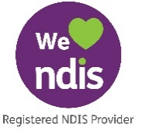
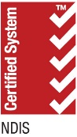
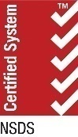
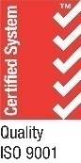
Tel: 1300 780 789
Job-matching | Training | Support | Careers | www.bizlink.asn.au

