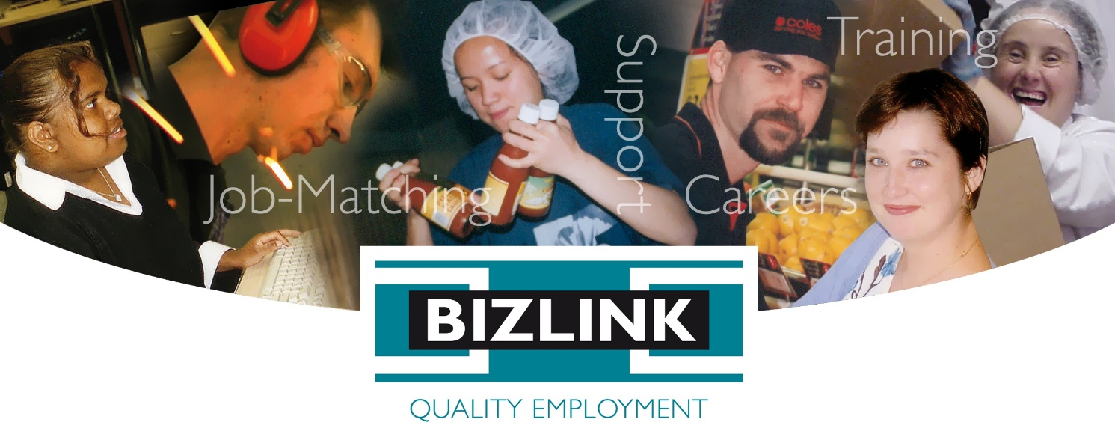

Indigenous Employment Strategy

The BIZLINK Board, management and employees acknowledge the traditional custodians of the land on which we work and their continuing connection to land, waters and community. We pay our respects to their cultures and to elders past and present.
Please note that in Western Australian, the term “Aboriginal” is preferred to “Indigenous” as Indigenous refers to both Aboriginal and Torres Strait Islander people. In this document we refer to either Indigenous or Aboriginal as appropriate to the context.

Aim and Scope
The BIZLINK Indigenous Employment Strategy aims to increase the representation of Aboriginal people working at or with BIZLINK. In addition, it aims to improve service access and outcome for Aboriginal clients.
This strategy covers activities related to the engagement and retention of Aboriginal people both within and external to BIZLINK. It includes the:
- Recruitment, training and retention of Aboriginal people employed by BIZLINK
- Service access for Aboriginal clients
- Promotion and job-matching of Aboriginal clients
- Training and retention of new or existing Aboriginal clients who are already employed
- Cultural awareness initiatives and training

Key Principles
- We value an inclusive and diverse workplace
- We recognize the diverse knowledge, skills, traditions and cultures of Aboriginal people

Strategies

Collection of Equity Data
BIZLINK employees are asked to complete the ‘Applicant and Employee Details’ form which includes an optional section regarding Equity Data - ‘Equal Employment Opportunity, for our inclusion targets (optional)’. This includes a tick box to identify as Indigenous.
BIZLINK will encourage employees to provide Equity Data and will assure employees that such information will not affect their selection or promotion opportunities. Employee selection, training and promotion practices are based solely on merit. Applicants and employees are considered for employment and promotion without regard to race, age, sex, sexual orientation, gender history, marital status, family status and responsibility, political and religious conviction, disability, illness or pregnancy. BIZLINK is an equal opportunity employer, we welcome applicants with disability, Aboriginal and Torres Strait Islanders and people from culturally diverse backgrounds.
Client Equity Data is included on the Department database and clients can choose to disclose.

BIZLINK Employee Recruitment
Management will aim to attract Aboriginal people to consider working within BIZLINK and will facilitate engagement through our recruitment procedures. Managers and employees will refer to the BIZLINK Policy on Equal Employment Opportunity which states that employee selection is based on merit.
Managers will consider the content of our job advertisements and our website as regards attracting Aboriginal people.
Managers will provide flexible interview and selection processes that are culturally appropriate with reference to the ‘NDS Aboriginal Torres Strait Islander Employment Guide Toolkit (2019)’. Managers can provide additional assistance to any applicant as required to explain the selection process and how best to address the Selection Criteria and prepare for the interview.
Managers can invite applicants for a workplace visit prior to a formal interview to meet members of the BIZLINK team and become comfortable with the work environment. Managers may choose to convene applicant interviews in a less formal environment that is welcoming and relaxed.
Managers will consider work trials, work experience, School Based Traineeships, Work-based Traineeships, flexible employment options, including naturally occurring vacancies, job creation, job restructuring and job sharing to appropriately engage Aboriginal people.

Aboriginal clients registering with BIZLINK
BIZLINK will aim to attract Aboriginal people with disability to consider registering with BIZLINK and will facilitate service access through our policies, procedures and employee training. By increasing the number of Aboriginal clients using BIZLINK services we can build our reputation as a service of choice for employers seeking to engage Aboriginal people and diversify their workplace.
Employees can proactively promote BIZLINK as a service seeking to support Aboriginal people with disability, particularly as regards direct registration pathways via Schools and Community-based organisations. BIZLINK will seek out community partnerships with Indigenous organisations to share resources and promote the registration of Aboriginal people with disability.

Employers Recruiting BIZLINK Aboriginal Clients
- BIZLINK will promote Aboriginal people with disability to employers to increase their participation in employment.
- BIZLINK will provide job-matching and on-the-job support to meet the individual needs of each client and the employer’s requirements.
- BIZLINK will reference this strategy to provide information to employers (co-workers) on how best to engage and retain Aboriginal clients.

BIZLINK job-retention rate of Aboriginal people
BIZLINK will aim to provide Aboriginal employees with opportunities for skills and career development. Managers will be encouraged and supported to provide individually designed professional development opportunities for all BIZLINK employees in accordance with their Performance Appraisal, Key Position Requirements and Training Record.
Managers may implement flexible employee support strategies including mentor support and holistic or pastoral care (considering broader issues which may be outside of work e.g. personal and social wellbeing, health, social issues and emotional support) and will utilise community or natural supports wherever appropriate.
Managers and employees will refer to the BIZLINK Policy on Equal Employment Opportunity which states that employee training and promotion practices are based on merit.
Managers are encouraged to access education and training, including work-based traineeships, to continuously improve and enhance the skills and knowledge of all BIZLINK employees.
Aboriginal employees who resign or exit BIZLINK for any reason will be encouraged to complete an exit survey/interview in line with the BIZLINK policy and procedures on the exit interview for all employees. This information can be used to improve our retention and attraction of Aboriginal employees.

Employee / Employer Training
BIZLINK employees and employers (co-workers) will be provided with information and/or opportunities for training and education regarding creating and maintaining a supportive and culturally respectful workplace. Ensuring Aboriginal employees have positive experiences in their workplace with the aim of improving retention rates.
Managers will provide resources and seek out training opportunities to ensure that all employees have access to information regarding the maintenance of a culturally respectful workplace, which can be shared with employers (co-workers). BIZLINK will provide ongoing cultural awareness raising and cultural competence development opportunities for all employees.

Fostering a Culture of Inclusion
BIZLINK will promote events that raise awareness of First Nations People achievements and celebrations, for example, Reconciliation Week and National Aboriginal and Islander Day of Celebrations Week (NAIDOC), using, for example, Bizzybodies newsletter, Facebook, website and posters as appropriate.
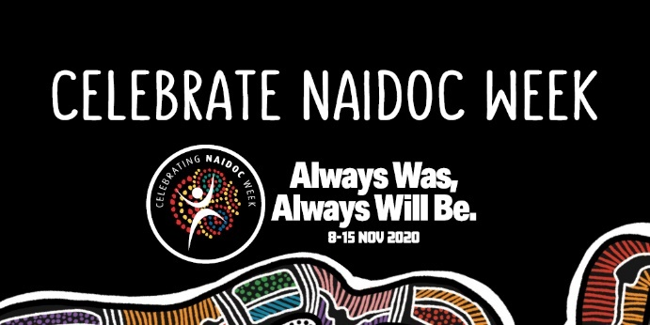
Positive communication and attitudes are encouraged from the perspective that the language and terminology used provides direct evidence of our employee’s values e.g. employees speak positively and respectfully about First Nations People and avoid the use of labels or derogatory language with regard to age, gender, race, culture, religion or disability.
Employees will refer to the “Welcome to Country and Acknowledgement of Traditional Owners and Custodians Protocol”.
BIZLINK will share this Indigenous Employment Strategy as a resource for our employers who currently engage or who are seeking to engage Aboriginal people. It will be available publicly on our website www.bizlink.asn.au/news-info

Engaging with Aboriginal people
The following is an extract from “Working with Aboriginal People NDS WA November 2010” p 15 – 17. Note some of the practices may need to be modified due to COVID e.g. access to toys, hand shaking. Reading this, you will find that the practices are beneficial for working with any person, they are respectful and promote a relaxed and welcoming environment and personable approach:

Making people comfortable Your office, or the place you meet people needs to be welcoming and culturally secure from the reception area onwards. Some people may bring children or other family members. Consider a larger meeting area, a box of toys and child friendly items, pencils paper to draw on, in the reception area and office. (Note toys etc may not be available due to COVID safety).
Consider allowing people to be seated facing the door. This could avert feelings of being trapped or closed in and will help to alleviate tension caused by unfamiliarity.

Try not to sit face to face across a desk with people, shift yourself to the side. Where possible, position your furniture so that you can sit to the side of your desk when talking with people. This is more comforting, and sets up an environment for yarning or relaxed conversation and helps to create an atmosphere that is not so tense and rigid. Sitting face to face across a desk can be uncomfortable to many Aboriginal people.

Simplify paperwork It can be a very uncomfortable and uneasy decision for an Aboriginal person to seek your assistance and attend scheduled appointments in an office environment. The initial appointment can be easier if you keep it short. Try simplifying the forms or electronic process and just do the necessary paperwork such as registration and signing the privacy act details.
Note: on your forms where it requests, are you Aboriginal or Torres Strait Islander you should also add “do you identify yourself as an Aboriginal or Torres Strait Islander”? Some people choose not to identify.
Visually comforting objects for your office Aboriginal people are very patriotic about Aboriginal colours. The colours facilitate a sense of belonging, kinship and pride. Organisations could have the Australian, Aboriginal and Torres Strait Islander flags represented in your office. Paintings and other art is helpful too. If you have an Aboriginal painting or other art know who the artist is, and the story behind the painting, this is great as an ice breaker.

Written Information Some Aboriginal people may not have adequate literacy and/or numeracy skills. If you suspect that this is the case, be sensitive and adapt information accordingly.

Keep a harmonious atmosphere in your office If appropriate play music in your office. Music is a common conversational topic. You can use it as an icebreaker to assist in breaking down communication barriers.

Empower people This can be achieved by ensuring people clearly understand everything you are trying to achieve together and allowing people to contribute and direct conversation. Keep people actively engaged in the whole process.

Never make a promise or commitment that you may not be able to fulfil.
Where appropriate, reiterate your organisations privacy policy Aboriginal people can experience discomfort if they feel that others know or may have access to their private information. Periodically assure people that their personal information is kept secure and private.
Rapport development made easier Share some of your own personal information during early rapport development. A common factor you may have is children, music, recreation or sport. Remember the three most important aspects to all Aboriginal people are Family, Spirituality and the Land. As an icebreaker, you could talk about your children, nieces, nephews etc. You could add why you are passionate about your chosen career and how you started in this field. Try to establish a relaxed, cheerful family orientated atmosphere. It is not good practice to get straight into business.
Eye contact can be offensive to some Aboriginal people Some Aboriginal people can be offended by direct eye contact, even more so with staring. You will know if eye contact is offensive by the amount of or lack of eye contact your client initiates. It is better to avoid eye contact on initial meetings.
First time you meet a person Always go out and greet people: offer to shake their hands, being aware of eye contact (and COVID safe practices). Do not be offended if the handshake is not reciprocated. Some people may choose not to shake your hand: this can be the case with some Aboriginal Women. There is little chance of offending if you offer a handshake but there is more of a chance of offending if you do not. Address elders by the title, Mr or Mrs.
Questioning If you ask for answers to an important question always allow the person the time they need to answer, there may be long periods of silence before the question is answered.
Beware of pre-conceived attitudes and prejudice Do not pre-judge a person based on clothing, mannerisms, confidence or their verbal communication. Aboriginal people can be very down to earth. They may not be as concerned with their outside appearance as the wider population. An Aboriginal person’s status is not based on appearance, self-image, money, education, or employment. It is based on their community standing and social status.
An Aboriginal person’s speech may switch between talking in mainstream English to Aboriginal English. Aboriginal English is an accepted language in most Aboriginal communities in Australia. It is a mixture of English, local slangs and key words in local Aboriginal dialects. Each community has its own version of Aboriginal English, but it is easily transferable between communities.
You don’t look Aboriginal? Under no circumstances should you mention to an Aboriginal person that they don’t look Aboriginal, nor ask them how much Aboriginal is in them. Saying “I would not have picked you as an Aboriginal” can also be insulting. If a person identifies as an Aboriginal, then this should never be questioned.
End of Extract.

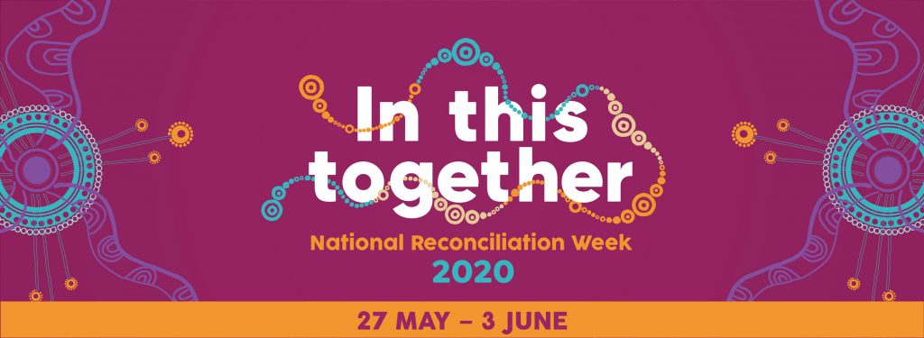

Welcome to Country and Acknowledgement of Country / Traditional Owners and Custodians Protocol
Recognising traditional owners at meetings and inviting Aboriginal Elders to give a ‘Welcome to Country’ ceremony at special events is one way we can show our respect for Australia’s first people. This protocol can be used by employees as a guide to respectfully acknowledge the traditional owners and custodians of the land at meetings and events and describes when a local Elder should be consulted about holding a traditional ‘Welcome to Country’ ceremony or when it is appropriate to use an Acknowledgment of Traditional Owners and Custodians.

Welcome to Country
A ‘Welcome to Country’ is when the traditional owner and custodian of the land or Elder welcome people to their land. This can be done through a speech, dance, song, traditional smoking ceremony or a combination of these.
Traditional owners and custodians should be acknowledged when opening a significant event or new site, particularly involving larger numbers of people or when: Bringing people from outside the organisation together; People have travelled to meet together from other areas; and when discussing issues relating to Indigenous Australians and when Indigenous Australians are attending. Contact with the traditional owners/custodians can be made to discuss what would be appropriate for the event.
How should a Welcome to Country be organised? Following discussion with the Managing Director, contact can be made with the local Aboriginal Land Council (South West Aboriginal Land and Sea Council), Local Government or State Department for Indigenous Affairs (Western Australian Department of Indigenous Affairs) to help with identifying the traditional owner group/s and if they have previously provided Welcome to Country ceremonies.
The Welcome to Country ceremony should be the first activity at the event. After the ceremony, the following speaker or MC should thank the Elder/s who provided the ‘Welcome to Country’ and then acknowledge the traditional owners of the land by using the ‘Acknowledgement specific to location and community’.
‘Welcome to Country’ can only be carried out only by the Traditional Custodians of the land on which the meeting takes place. If the Traditional Custodians cannot perform Welcome to Country, then the next step is to ask another Aboriginal person and/or senior person to perform ‘Acknowledgement of Country or Acknowledgment of Traditional Owners and Custodians’.

Acknowledgement of Country / Traditional Owners and Custodians
If the Traditional custodians are not available for a ‘Welcome to Country’, an ‘Acknowledgement of Country’ may be conducted. This can be done by Aboriginal and non-Indigenous people.
At the start of a meeting, it is respectful for a senior person e.g. Managing Director or Chairperson, and/or an Aboriginal person to recognise the traditional owners and custodians of the land on which the meeting is occurring.
General Acknowledgement Use if unsure of the name of the group or if there is more than one group to be acknowledged:
“I’d like to begin by acknowledging the traditional owners and custodians of the land on which we are meeting today. I would also like to pay my respects to the Elders past and present and extend that respect to other Aboriginal people present here today.”
Specific Acknowledgement
“To begin proceedings, I wish to acknowledge the people of the Noongar Nation who are the traditional owners and custodians of the land on which this meeting is taking place. I would also like to pay respect to the Elders both past and present and extend that respect to other Aboriginal people present here today.”

References and Definitions
- National Standards for Disability Services
- Disability Employment Services Grant Agreement
- NDS Aboriginal Torres Strait Islander Employment Guide Toolkit (2019)
- Working with Aboriginal People NDS WA November 2010
- Aboriginal or Torres Strait Islander person’ means:
(a) a person who is identified as such on the Department’s IT Systems; or
(b) a person who:
(i)is of Aboriginal and/or Torres Strait Islander descent;
(ii)identifies as an Aboriginal and/or Torres Strait Islander person; and
(iii)is accepted as such in the community in which the person lives or has lived.
Ref: DES Grant Agreement Definition
In Western Australian, the term “Aboriginal” is preferred to “Indigenous” as Indigenous refers to both Aboriginal and Torres Strait Islander people. It is an international term adopted by the United Nations to identify all Indigenous peoples in a global context (ref: Working with Aboriginal People NDS WA November 2010). Also reference https://aiatsis.gov.au/explore/articles/indigenous-australians-aboriginal-and-torres-strait-islander-people and https://www.commonground.org.au/learn/aboriginal-or-indigenous which explains the use of the term Indigenous Australians, First Nations People or Aboriginal and Torres Strait Islander people.
- Noongar (alternate spelling: Nyungar / Nyoongar / Nyoongah / Nyungah / Nyugah / Noonga) people are the traditional owners of the south-west of Western Australia from Geraldton on the west coast to Esperance on the south coast. Their country extends from Jurien Bay in the north to the southern coast, and east to Ravensthorpe and Southern Cross. However, it is always good practice to seek advice to confirm who the traditional owner group/s are in the area of the meeting.

- Client refers to people with disability who have registered (or who seek to register) with BIZLINK for a service to find and maintain employment.

Images
Indigenous images are from https://www.naidoc.org.au/ and https://nrw.reconciliation.org.au/posters-and-resources/
Aboriginal and Torres Strait Islander people should be aware that the BIZLINK logo contains images of people who have died. We have family permission to use these images.

Review
The Indigenous Employment Strategy will ordinarily be reviewed every three years, however, if at any time the legislative, policy or funding environment is so altered that the document is no longer appropriate in its current form, it will be reviewed immediately and amended accordingly.

About BIZLINK
BIZLINK is a leading West Australian not-for-profit disability employment service. We selectively match job seekers to fill the criteria of each vacancy and provide individualised on-site training, support and advice. Australian Government funding makes our service FREE.
Servicing the Perth suburbs since 1992, we have a network of hundreds of employers that benefit from our job matching and on-site training. We achieve reduced turn-over, lower absenteeism and employees who produce the quality and quantity to meet employer needs.
When making a choice, unlike many other providers, BIZLINK is:
- WA based and services only the Perth metropolitan
- Not-for-profit - all our funding goes into our service, not to shareholders
- Dedicated to securing and supporting inclusive employment in the Perth suburbs
- We assist working age people with all types of disabilities, barriers and backgrounds
- Tailored to your individual needs. We work with you to achieve your employment goals and secure sustainable ongoing open employment
- Experienced in personal job-matching and providing individual assistance including on and off-site training and support
- Quality endorsed with Disability Support Certification and ISO 9001 Quality Management

Getting Information Your Way
BIZLINK assists people with a range of abilities. Staff can read and explain this information or BIZLINK can provide the information in different ways, such as, large print, another language or electronically; e.g. emailed to you as a word document, as needed. Discuss with your Coordinator or contact BIZLINK.

Like Us on Facebook
BIZLINK has a Facebook page. We use it as an extension of our Bizzybodies newsletter and to connect with us and stay informed. Our Facebook page promotes our service, shares good news stories, provides relevant Department updates and shares information about BIZLINK services
www.facebook.com/bizlinkqualityemployment

Website
Our website provides information about BIZLINK for job seekers, employers, schools and community organisations. We post our policies, reports and newsletters to the website www.bizlink.asn.au
BIZLINK acknowledges the support of the Australian Government Department of Social Services which provides Employment Support Services funding.

1300 780 789
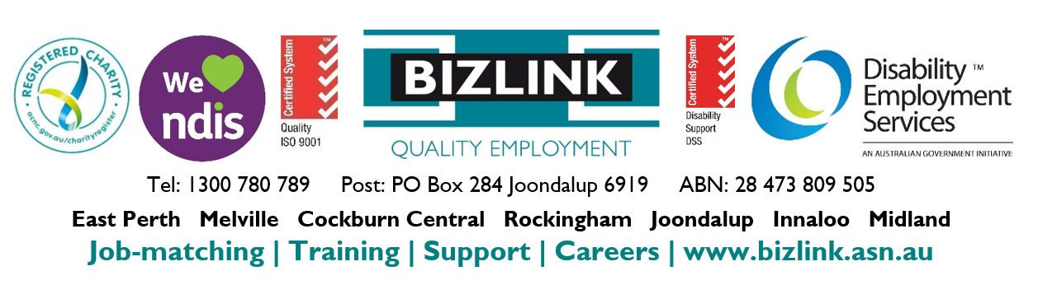
To discuss how BIZLINK could be the BEST provider for you

