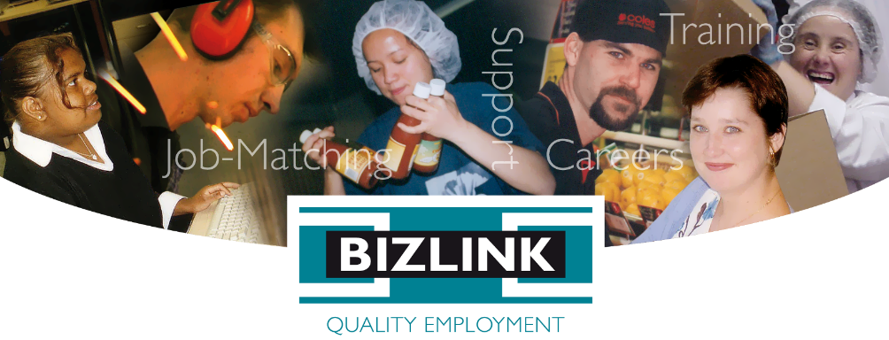
September 2023 Volume 107

BIZZYBODIES

Employer of Year Nominees
BIZLINK employees have nominated the following employers for the 2023 Employer of the Year Award:
- South Metropolitan Health Service (Fiona Stanley Hospital)
- IRS Welshpool
- City of Rockingham
- Woolworths Port Coogee
- Perth Motor Bodies (PMB)
- Jason Windows
- Officeworks (Jandakot & O'Connor)
- Australia Post (Joondalup)
- Assisting Your Life to Achieve (AYLA)
- Motium
- JAD
- Ritz Party Hire, Rockingham
Since 2000, we have presented the BIZLINK Employer of the Year Award to the employer that has demonstrated outstanding support of open employment access for people with disabilities. The categories considered for the award are:
- Number and proportion of staff that are BIZLINK workers
- Level and nature of interaction workers have with staff and customers
- Level of support demonstrated to facilitate training and inclusion
- Commitment to a fair day’s pay for a fair day’s work
Previous winners of the BIZLINK Employer of the Year Award - Employer Awards - BIZLINK
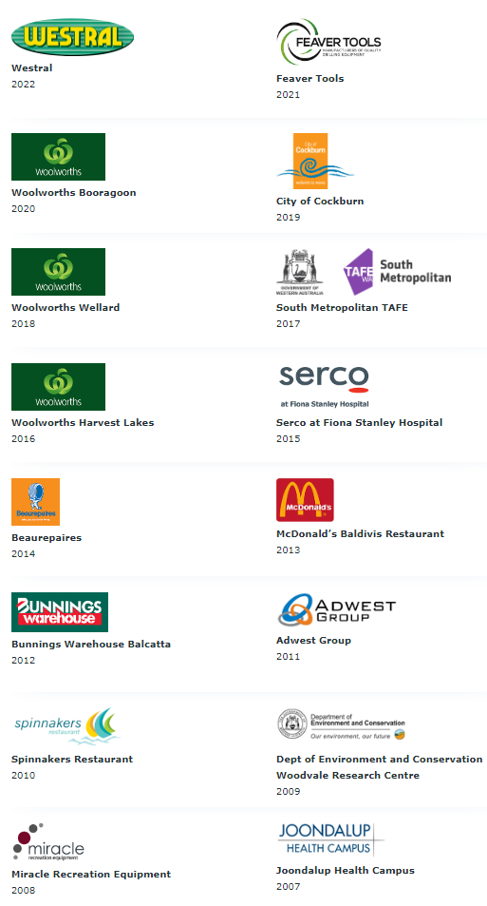

My Little Bookshop
Tayla was nominated for the Rockingham Kwinana Chamber of Commerce Mineral Resources Regional Business Awards. Tayla has been employed at My Little Bookshop on the Rockingham Foreshore since July 2022, and was nominated for Employee of the Year by employer Kerry and made the top 5 finalists of 40 applicants.
Kerry was impressed at how Tayla’s administration and customer service skills have improved since she first started working at My Little Bookshop. Kerry wanted to celebrate Tayla’s contribution to her bookshop saying that her creativity plays a significant role in the business. She describes Tayla as a “ray of sunshine” and a valued member of the team who fosters a positive work environment.
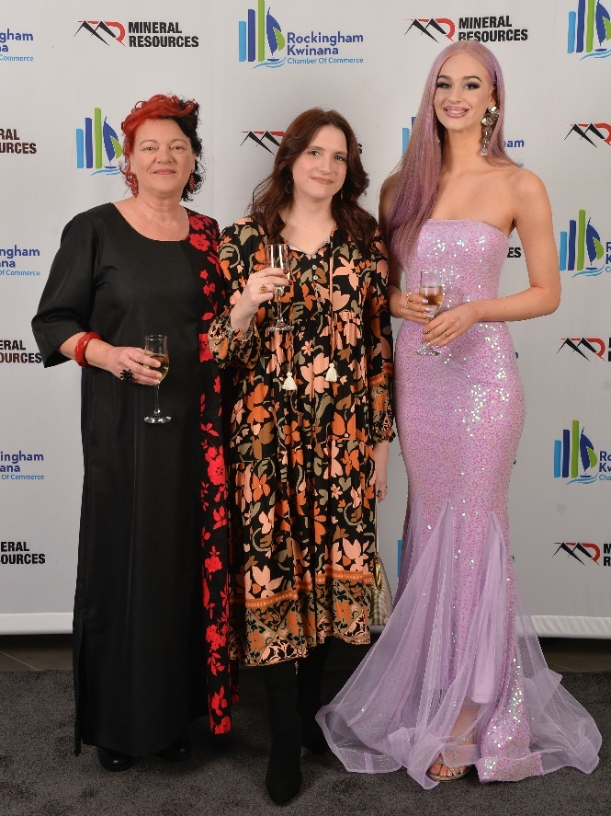
Kerry (Employer/Owner), Aimee and Tayla (employees).
Story by Carmel Support Coordinator BIZLINK Rockingham.
My Little Bookshop have fantastic posts on social media, the store is amazing.
Link to My Little Bookshop story

Notice of Annual General Meeting
TUESDAY 17 OCTOBER 2023
5.00 pm to 7.00 pm
Tompkins, Cnr Dunkley Ave and Canning Highway, Alfred Cove
Meeting will be followed by presentation of the:
- DEA Service Award
- BIZLINK Service Award
- Tara Doyle Award
- BIZLINK Employer of the Year Award

Refreshments will be served and membership applications accepted at the door ($5.50)

Membership of BIZLINK Incorporated Association
BIZLINK is an Incorporated Association. Membership of the Association is voluntary. Members have voting rights at general meetings so have an opportunity to influence the current practices and future of BIZLINK. Anyone with an interest in BIZLINK may apply to become a member. Membership forms will be available at the AGM, or available on our website at BIZLINK News & Info or you ask for one when you RSVP.
RSVP by Thursday 12 October 2023
Email admin@bizlink.asn.au / call 1300 780 789
Attendance is voluntary.

SAI Global Quality Assessment
In June 2023, we successfully completed our External Quality Audit for our Disability Employment Service (DES). This was two weeks of being reviewed against the National Standards for Disability Services and ISO 9001. Thanks to those who volunteered to participate in the audit by talking with Grisha and Zel from SAI Global, it was greatly appreciated.
More recently, we completed our audit against ISO 27001, and have been recommended for an upgraded certification to ISO 27001:2022. NDIS was also audited in September, and we are waiting for the final report.

BIZLINK Certifications
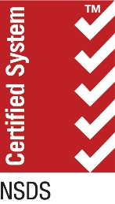
National Standards for Disability Services (NSDS) Certification at all sites, since 2002. Disability Employment Services (DES) must have this certification to operate.

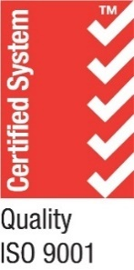
ISO 9001 Quality Management System (QMS) Certification Head Office since 1998. QMS provides a framework for improving quality across our service in a consistent and reliable manner.
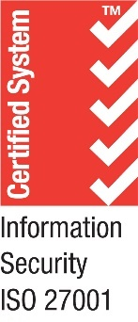
ISO 27001 Information Security Management Systems (ISMS) Certification Head Office since June 2022. ISMS provides a framework to continuously improve our information security and focuses on keeping information confidential.

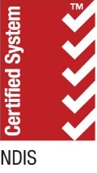
NDIS Employment Supports Certification all sites, since 2022. Registered NDIS services must have certification to operate.

Protecting Your Information
BIZLINK has Right Fit For Risk (RFFR) Cyber Security Accreditation. The Department of Employment and Workplace Relations (DEWR) requires providers, like BIZLINK, to meet and comply with certain information security requirements. RFFR Accreditation means that a Provider has met these requirements. More information Right Fit For Risk Cyber Security Accreditation DEWR.

Anytime Client Survey
Clients can give feedback about BIZLINK at any time. We have a Survey Monkey link or QR Code at the feedback page on our website BIZLINK Feedback.

Complaint Process
Are you unhappy with the quality or safety of the services and supports you receive from BIZLINK? The first thing you should do is talk to your Coordinator, a BIZLINK Manager or someone you trust. More information: BIZLINK Standards & Policies If you have spoken to BIZLINK or someone you trust and feel like the issue has not been resolved, you can contact:

DES Complaints:
Free call 1800 880 052
The Complaints Resolution and Referral Service, More information: Complaints and Referral Processes | dss.gov.au

NDIS Complaints:
Free call 1800 035 544 or TTY 133 677 More information: Feedback and complaints | NDIS

Sunflower Initiative
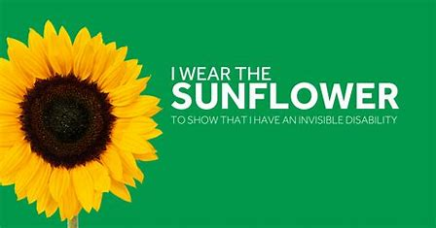

The Hidden Disabilities Sunflower is a tool to voluntarily share that you have a disability or condition and that you may need assistance, understanding, or more time in shops, at work, on transport, or in public spaces. More information: HDSunflower | hdsunflower.com It is not for everyone, but some people may benefit from this. Aside from asking someone if they might need help, there are five main things you can do if you see someone displaying sunflower gear:
- Be kind
- Listen closely
- Have patience
- Don't judge
- Show respect
"These are basic common decency requirements, but we like to think that the sunflower helps remind people to build a more inclusive society".

WA Mental Health Week 2023
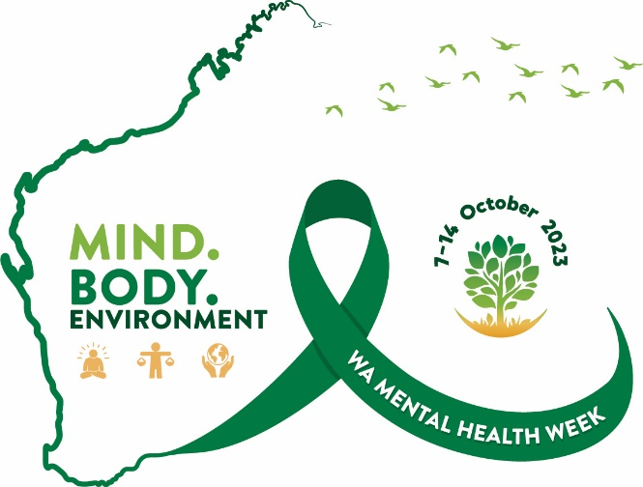
Mental Health Week is a special week celebrated nationally every October, and it's timed to coincide with World Mental Health Day on October 10th. In Western Australia, it's organized by the Western Australian Association for Mental Health, with support from the WA Mental Health Commission. This week is all about raising awareness of how things like our living conditions and social factors can affect our mental health. It also promotes ways to prevent mental health issues and keep people mentally healthy.
In 2023, Mental Health Week in WA will take place from October 7th to October 14th, and it has a theme: "Mind. Body. Environment." This theme is all about emphasizing how important it is to take care of ourselves by looking after our minds, bodies, and the environment.
When we invest time and effort in looking after our mental health, it helps us stay strong and clear-headed during tough times. It allows us to handle stress, anxiety, and make good decisions, seek support, and find solutions. By focusing on our mental well-being, we learn to take care of ourselves and show ourselves kindness, which makes us more resilient when facing challenges.
Our physical health, both inside our bodies and in the world around us, has a significant impact on our mental health. What we eat, how we move, the state of our environment, and the quality of our homes and neighbourhoods all play a role in creating healthy communities and individuals - so it's important to recognize and address those experiences so we live our best lives. More info is available at Home | Mental Health Week

Ritz Party Hire
Ritz Party Hire & Supplies Finalists 2023 Rockingham Kwinana Chamber of Commerce Mineral Resources Regional Business Awards. Michele is our employer from Ritz Party, she was nominated for her excellent customer service, reliability, quality standards, dealing with the public and her positive contribution to the community. Michele embodies the company values “Ritz Party Hire is your one stop party shop”.
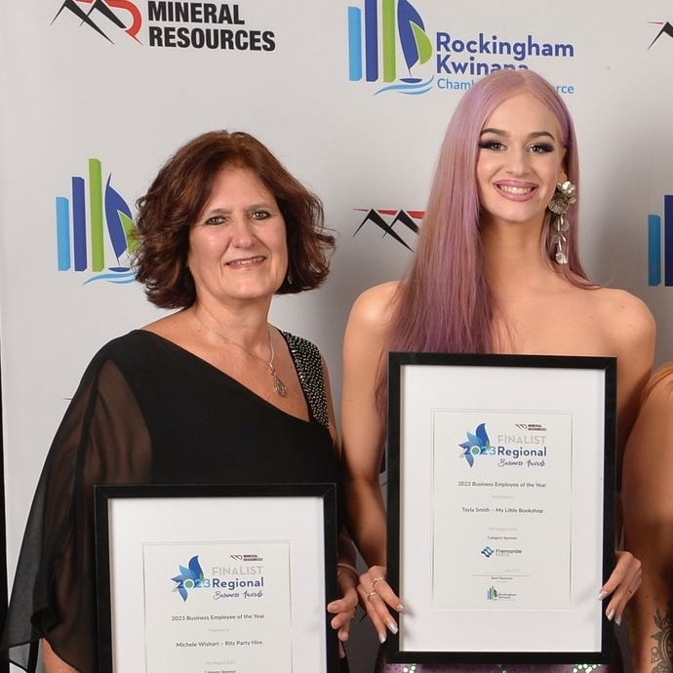
Michele (Ritz Party Hire) and Tayla (My Little Bookshop).
Story by Carmel Support Coordinator Rockingham.

Melville Cares
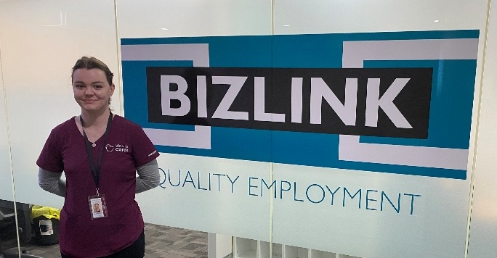
Alex out the front of the BIZLINK Melville office
Over the past year, we've seen Alex embark on a career development journey to gain employment with Melville Cares. Alex has done study and volunteer work to build her skills to reach her employment goal. With the support of Job Search Coordinator Cush, Alex is now proudly employed as a Domestic Support Worker. Her employer recently sent a glowing email commending her initiative.

3 New Office Locations
BIZLINK has opened three new offices, Clarkson, Morley, and Cannington, to provide improved access for clients across the Perth metropolitan. We now have the convenience of 10 office locations with Clarkson, Innaloo, Morley and Midland - North / East Perth, Melville, Cockburn and Rockingham - Central and West Metro and Cannington primarily providing NDIS.
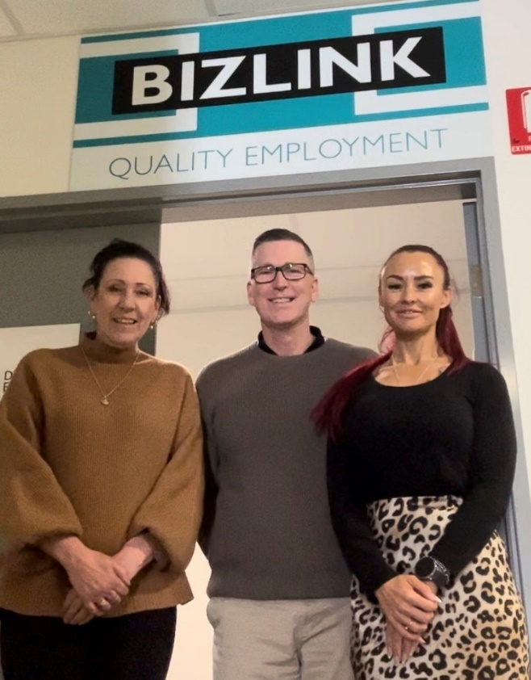
Bronnie, Lee, Megan
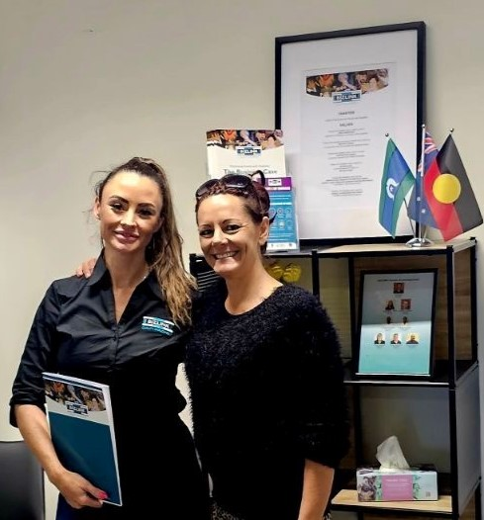
Alicia in front of the Cockburn office with her artwork
Megan with first Clarkson client Amanda

Career Expo
Coastal Lakes College Pathways and Careers Fair BIZLINK was represented by Suresh, Job Search Coordinator, and Stephenie, Team Coordinator Rockingham. Students and parents were given an opportunity to chat with providers, potential employers, and could find out about Year 11 & 12 College pathways, post-college employment, and funding options.
Students who are finishing school, or who want to find out more about our NDIS and DES employment programs can call 1300 780 789.
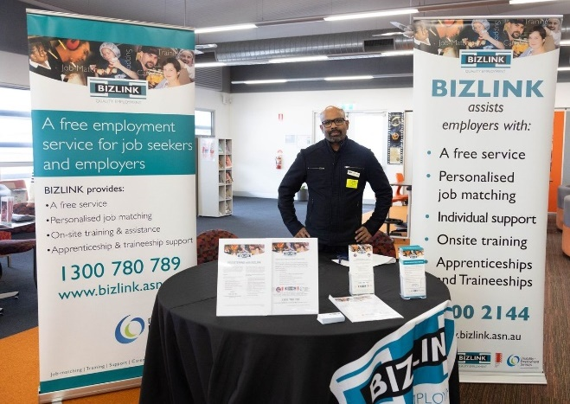
Suresh

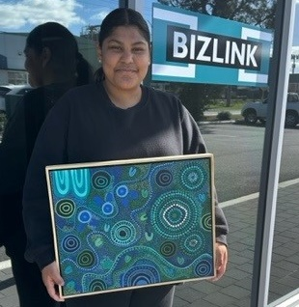
First Nations Art for our Office
Aboriginal Artist Alicia gifted “The Gathering” to our Cockburn office. The picture tells the story of Elders going to different camping sites and gathering to stay safe and to look after each other. We are very proud to promote Alicia's art.

Woolworths Port Coogee
Rosemarie nominated Woolworths Port Coogee for the 2023 BIZLINK Employer of the Year Award. They currently employ 7 clients and have recently interviewed for more staff. They provide a relaxed atmosphere, and an informal interview process. Janaya, Store Manager, prefers to call it meet and greet, everyone is made to feel so welcome by the store.
Raymond has been working at Woolworths Port Coogee since 2018 doing stock replenishment. Due to Raymond’s work ethic, commitment, and reliability he was given the opportunity to move to Customer Service. Raymond has been working in customer service/checkout for 2 years and thoroughly enjoys interacting and chatting with the customers.
Raymond was awarded Employee of the Month (July) by his managers. Raymond is a highly valued team member who always turns up for every shift with a smile and is happy to be at work.
Raymond continues to provide excellent customer service and he is loved by all the regulars who shop at Woolworths Port Coogee. Raymond said “I enjoy wearing my Woolworths uniform with pride. Working in customer service over the last 2 years has taken me out of my comfort zone. I am now confident when interacting and engaging with our valued Woolworths customers”.
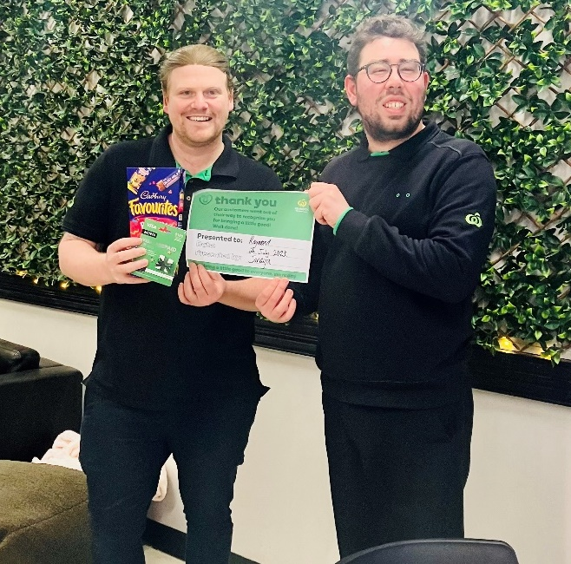
Mark, Assistant Store Manager and Raymond
Story by Rosemarie, Support Coordinator, Cockburn.

Dome Secret Harbour
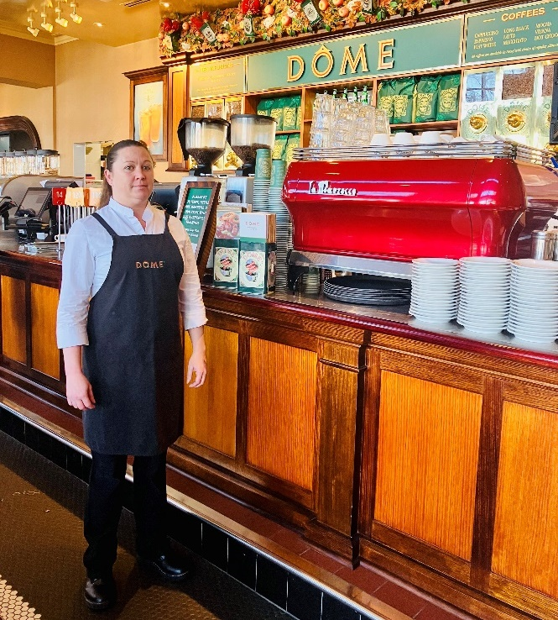
Kristy
Kristy has worked at Dôme Secret Harbour since April 2022 as a DRA (Dining Room Attendant). Kristy loves her work and travels every day for over an hour. Kristy first started working at Dome Cockburn in November 2021, however, the Cafés lease expired, so Kristy was offered the opportunity to transfer and happily accepted the position. Kristy is a valued team member at Dome Secret Harbour and takes pride in her job and always ensures the upstairs Café is up to the Dome standards regarding quality and presentation. More recently, Kristy expressed an interest in order taking. Ashleigh (Dome Manager) has given Kristy the opportunity to do order taking when the Café is quiet so that Kristy can learn at her pace without the big rush with customers during their busy periods. Kristy continues to thrive in her role. Kristy said "When I first joined BIZLINK I hadn’t worked in over a year. I got a call from BIZLINK to do a work trial at Dome Cockburn. I got the job and Dome Cockburn closed down and I was given a transfer to Dome Secret Harbour. I take care of upstairs at Dome making sure it’s presentable at all times, this has helped me gain my confidence back and I believe in myself again. Rosemarie from BIZLINK has been amazing and comes out to see me once a week."
Story by Rosemarie, Support Coordinator, Cockburn.

Perth Motor Bodies (PMB)
Cush nominated PMB for the 2023 BIZLINK Employer of the Year Award. Lauren (HR), Daniel (Fabrication Supervisor), Troy (Fitting Dept Supervisor) and Joel (Paint Room Supervisor) have been tremendous when it comes to employee support and training, making employees feel welcome and fully supported.
PMB currently employ six BIZLINK workers. Duties range from electrical fitting, mine specification fitting of vehicle parts, paint room preparations and more. Tylar commenced last year, and is now doing an apprenticeship.
PMB has shown their commitment to our support team and have accommodated each employee and the hours of employment that suits their needs. Simon commented after his first couple weeks that he has not been happier and looks forward to the start of the week.
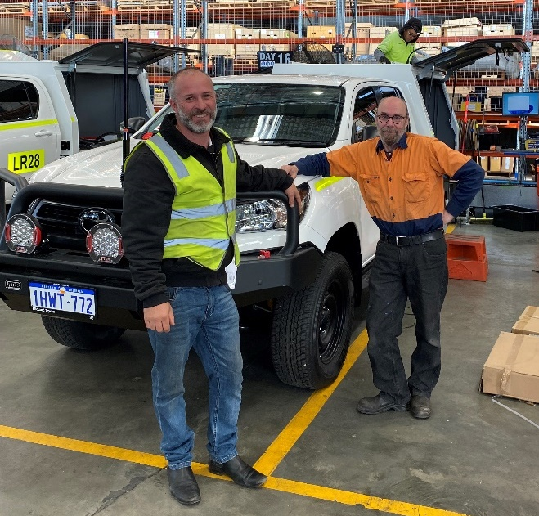
Troy and Simon
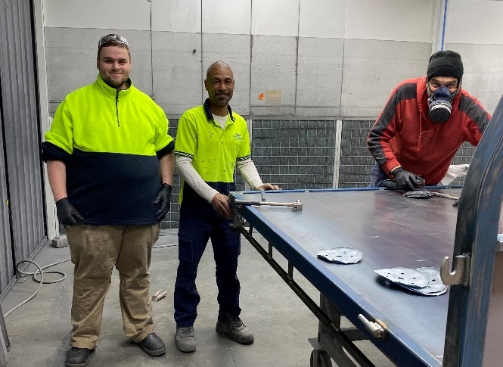
Jayden, Joel and Rayden
Story by Cush, Job Search Coordinator, Melville

Assisting Your Life to Achieve (AYLA)
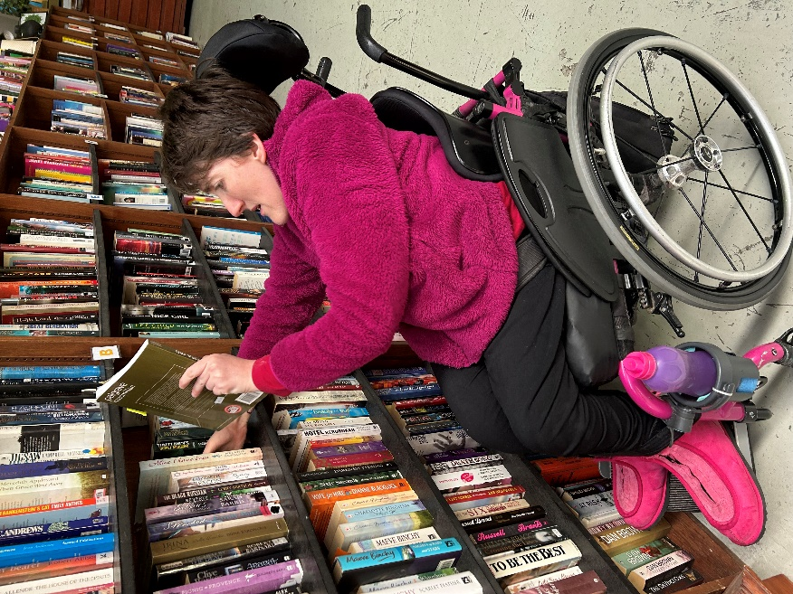
Katie
Paris nominated AYLA for the 2023 Employer of the Year Award. AYLA have shown a huge amount of support with our clients over the years and continue to work with us to ensure our clients are being given equal and fair opportunities to succeed. Amanda and another client started as volunteers then moved to paid employment then progressed into traineeships and are now team leaders. Katie is completing a Cert III in Community Services. AYLA encourage career progression which demonstrates inclusive employment.
AYLA have committed to hosting Charlotte in her School Based Traineeship Cert II in Retail with Fremantle Group training which we will be working towards transitioning Charlotte to a Cert III in Retail Traineeship at AYLA once Charlotte completes year 12 at SMYL. In addition to our clients in paid employment AYLA provide BIZLINK clients with volunteer opportunities, this builds confidence to progress to paid employment not only at AYLA but with other organisations. AYLA is an outstanding supportive employer.
Story by Paris, Job Search Coordinator, Cockburn Central

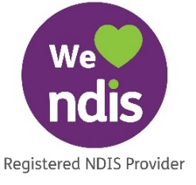
BIZLINK NDIS
If you have or add Finding and Keeping a Job funding in your NDIS plan, together we can:

- Support you to create a pathway that builds your skills.
- Work with you to establish your employment goals.
- Provide work experience opportunities.
- Build work readiness skills.
To Find Out More
Call 1300 780 789
Email ndis@bizink.asn.au

Getting Information Your Way
BIZLINK assists people with a range of abilities. Staff can read and explain this information, or we can provide the information in different ways, such as, another language or electronically, as needed. Please discuss with your Coordinator.

Choose BIZLINK
BIZLINK is a West Australian, not-for-profit, employment service. BIZLINK is dedicated to securing and supporting inclusive employment in the Perth suburbs and has done so since 1992.
Whether you already have a job or are looking for employment, choose BIZLINK for:
- A free service.
- Convenience of 10 offices across Perth.
- Personalised job-matching.
- Individual one-to-one assistance.
- On-site training support and advice.
- Apprenticeship and Traineeship support.

CONTACT
1300 780 789
To discuss how BIZLINK could be the BEST provider for you

